trtqllrd ^{qt} t€ !r-S il(ETIrTq
ffi
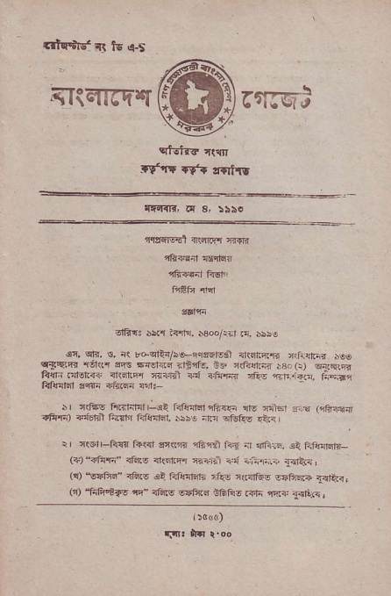
rt'tr lgl 66r"
rtltrFtrl c| a, laio
a&li'
sl6rj b5l1 l+rri. $oqrir .n D5€
_{€i,} ^{qtd,} s, i( rdqF<!/srqrrers.il d(cr@6 _{*liernr} j€! ^{qlEFd} nEr{r a'r6 rrcl< d <r5rte, tu r(?crni _{iB.,} (r) e*Fjrn ii${.:nor..' ihdrir{ iai:ri rn <,E{.ni rlie rr+i?.r. lnd! frfe|.n sffi iltrfl ldF
?ft.a +ndnl frilr _{6i.ai61,tnlnrd} ^{qR.€} n|g ^{FlFr} _{".d} (qfr<air
r I rrFs f4Rrrnt -ol
_{5ibe irar} ^{qtuf<v} {ii
i _{n(sr} ^{-f€{} f{r< F$|n 1Eln!1fa9 i 1nG:,a. oi Fir{'lw- ^{(+)'?ans"} <t4v <t(dfifr r.+.ii ^{-ii iii.i.ir} T<nir r ^{(!)} "sFfts" <tus dq,qrr{r,ii rfRs n(.flf6s ^{ssl},q.e} 3a€.<: _{r-)} ^{_tsftot?s} +- nf6o _{srfqE} ^{EEf!. @" a{i} 1{lle,
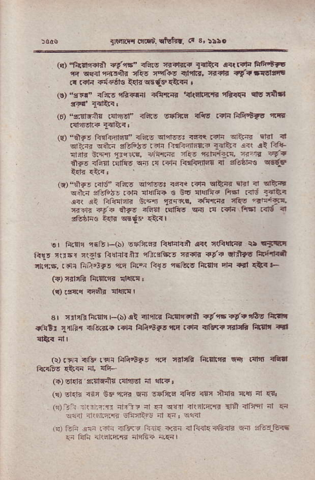
gen@ dd. ttutr!, <. &:tlo
(c)'f+$@1"1 ?t'ri' ^{<ft6 tt?Br.?} _{SqrV<} c<rr?r{ FtrttF 3 e{dnqrlin{ {!s Ff.s rtirrr, f,{fir i{rlFrslrri! r. rali f{ntrc &id wdtrcQr{i ,
^{l!)} _{"fr." rinE} '!a?.{ _{<,&{qi} ^{r{rafiqr,rd} nB.<ti rrv lrjlB
16) _{"4nrc+{} taiJd" .Fre s{Frln rlis .?l{ f{fr'i.{s ilir ^{.{lir!lz4} _{1414<} '
^{(€)} _{"lltre f<f@rd!" 3li!o} ^{q1:r$83} @q Rtn dtq slrl <! ^{qrt?. q&F} dliF r rrF faln4lir31dit. o !i ri+ _{niitr $.qa} '1rqls. _{<,iPc} 'rf{. nil{Qr, ft.rt ?v? nla6 nfi{i rsrias ^{w .{ .nnr f{{F 0l"{} _{"l sfsdns} qs6:e
(q)"{rtr! _{.nni" iEnv} ^{qr4qg:} <na _{!?ri} ^{qi.nr} rrr' n1 e|t'!t ood _{3i€io5r.aF !r4fe € 8.6} ^{ql{iid} fttt1 _{.<lrt} gtR< 6<( el fiFf4ril3 _{b.4} ^{'t} @!, atu.fiar '@s ?iEnTr. _{f,ill3 {9-? 21fo} ^{zftl} _{FrliE} ^{€r{l} r{ ^{!4ti fid|.dtt "l} !tugF€ Edr w6-.. {+rl
er rii?F r-ieF(s) sr'hdr &{r{ljil es( irE{rd tr El<t llrj _{rrn5r} ^{q(grc} _{Llin|rtu} ^{qfi.4*5} f,flrd 4tn ctil-?s fitt r.it rtr:6. _{.dr hi.'3*5} 'l!q liei li{e i5ero etrFl Elr .tl q+. F r{)qnrrB tusnrR rltn{,
^{(q)} tgilq n+r nJfinr
sr rirrB Fr$r r-(5) oi rnftr ft.:Fr{tn {e-n ?f? ros E|lr ^{nftti} _{1{n.} 4lss(. .?F fir{='badftn l?t{ nF!?fi{r6 Fr3li al
({ fta ^{rilb !?i lnn,nir} _{".n} 'lttft f{.{l!rn cq, dFr rEd (4) ddr'*?rEin _{.neM ni} qn?,
(n) sras ar5 sFn4d cln snlirs R6rs <ri +4a !.q fl {?' _{("_t_i} ^{_iir ?nr i5-n} _{"l} qn ^{qlrr} rrliE4B drn a ifi nr cn
rlir i1r.trm sft-{il* nt _{4n,} q?ql
tq) iiin .:n raEi irar? Fj iF ffi illi4E4li<fi wr :datr-fdnE {n tuFi .riilr4€ ilifi? nr€l
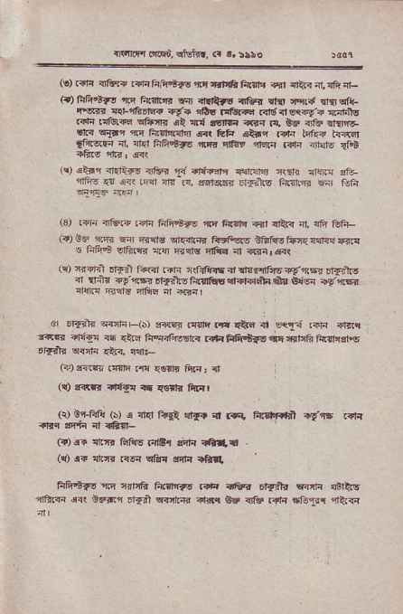
_{{r'nnq i,!r6.} ^{qtutj..} <r r,:!ro
^{(e)} .ria {frfi? .di rniq'if6 ^{'rr} _{sFrE 6r{li} ^{-irfl} {ER ni ?fi nr- ⁽⁹ _{ft&'Fas} ^{,trq} _{ftfr'F s{ rit'ltrs rj&rn} ^{qii'} iq{ ^{cfi|!Et&. rEE{! {4-inEr.} <a 1o!.{!r.€ ^{Rrsd@?{? s!:rts} t{f{ _{.rts!@} ^{qfffi.} .Q ad rqrfr {r'{ t{, BEt 4F rrrFl\t _{6r{} ^{q1*r} 4q ftsrralr a.r Clh 6tni .a'n if.? h.st _{lFqr{} fl, $d lie+ts ^{1tE 'larw 4s.{ rd-r nndq} {fo!
'., el a @hd rfFn € 4+Frn et"-j ^{r,e.} I'qj sp. r{, ererr r*to Firttn c. Ijtu
⁽³⁾ i?J- <fsr? .+f{ frFpbre ^{.nr} ft'|t Bt <PR ;r, rli tEf{- (?) Er _{4!.d} ^{qn'} _{nr4!} ^{qr!.{r:I"} aeFqs Btofisf.c{{dsnrr'.! € fi&.E sriiqrr Eri mitE nrfiq nt <rfirda(
rlr ir4?i E,Tir l+4 .ni ^{r{dff} d rlnflftu ^{?ga6e} o13E'r6 {i trj? ₄₎ ^{'!q} url?-G fir{ili {?l-d.i4 i? {Hq as 46d rm fizt*rlf{d nt €nl
_{6 Drf'il"} ^{qftF (bJ} erF! .{re .* dt6 .r sqii Rln <rrt.| frr.r ^{rFgl rq} <lrd liq.Gr6rn rrriFfttB-s.rifitifn6ntllat€ _{tFdtr} ^{q<ctn} r!r-r. ndF
^{(?)} fdti .{nrq .€ _{{srfr ftn'} :'t
⁽⁹ rd.n ?if!n ^{rr} lEfr fi..l
(v o_t-ftr! rlr r {l4 f'tl ri{. ^{.t} CE Fircr,qh'l _{q} q6 .Fq rn'ii { rafl-
(?),!+ arrfr GrFrq _{rdl& sdfr dt a} .
(9 ^{q?} _{1E3 !<Jn} ^{qrf{} 3di re|!
liF|!tsa6'ftq crha f{trlrrq _{lriq nC., Efilri.r Fni} qlttE 4ftG drr $d.!t Di?41 R'it-{n rf*{ _{Bt ?lfe rin *njTrr} nRrq
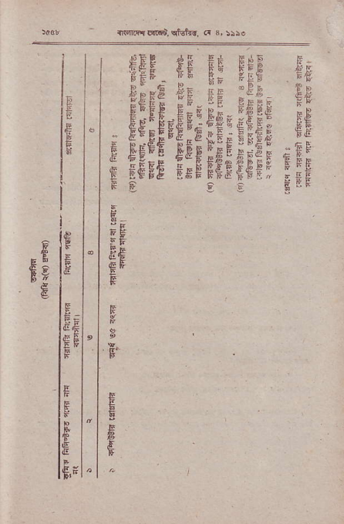
_{-rlllirdn6i.} ^{qiofr-r.} .r ^{3,} r5!.
€FF ec _{5t} s;E f*
_{eis€ fc-} ^{gE} ;ff- Ef
^{E}E
E€E€E'E
.EF
&
Eg
F
F P
E
F
ts
le
{,r
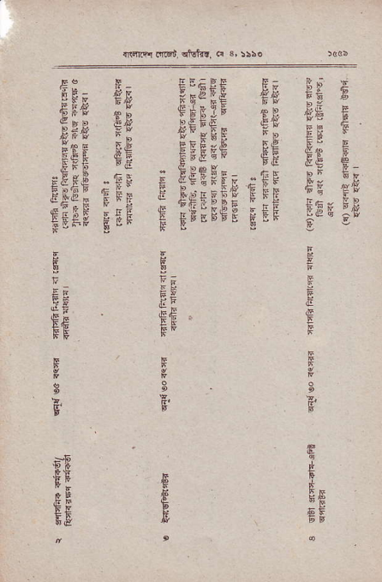
ftr rs EiEF€ _{{p} €r6
!ftrd. d.Ed. €rfuI}r. d 3,:\50
E€[E€EisE;Etr rt; t E-;[isrfft;, tr
; -
PF
{E€ .
FF
F
.E^{EE}F
5
F'
.tE eE
E.E
E
e ⁵E
F
&. 6F
_{4;i@ oFt, rist{r} ^{('} i, :}5.
E :FFfg Egff re EEEEtIEg
€ €
IE
E"
F
F
^{E}E_{p}
E. E^{E}F
g
E
€ ,
F
F
E, F
E
F
5
E
E
E
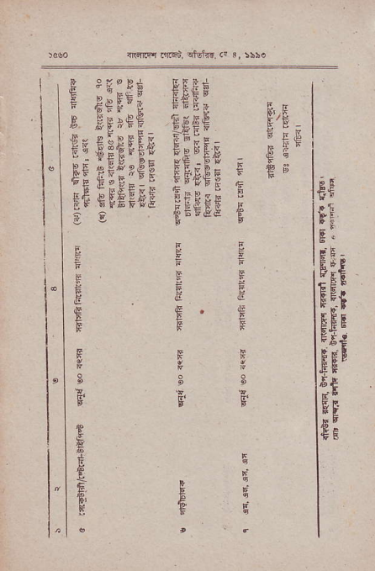
^{E:;} Fit Fef
FEE F.E " ^{F.i .9} uiI
st'
CA

